CSCI 345 Lab #1

Brandi Durham, Andrew Miller

**Think: why do some systems give root access by using: sudo su – assume root access without knowing the root password?**

A.) it is more usable to not require a password especially when a user already has physical access to a machine and is capable of executing privileged commands, but this assumption is obviously less secure. The system assumes that the user can execute commands as root for extreme administrative purposes because the user already knows the usage of sudo and su and has already provided credentials for sudo.

**Read your /etc/sudoers and explain what it is doing with your system**

A.) It is a file containing the users and user groups which are able to execute privileged commands with sudo

**Results of cat /var/log/system.log**

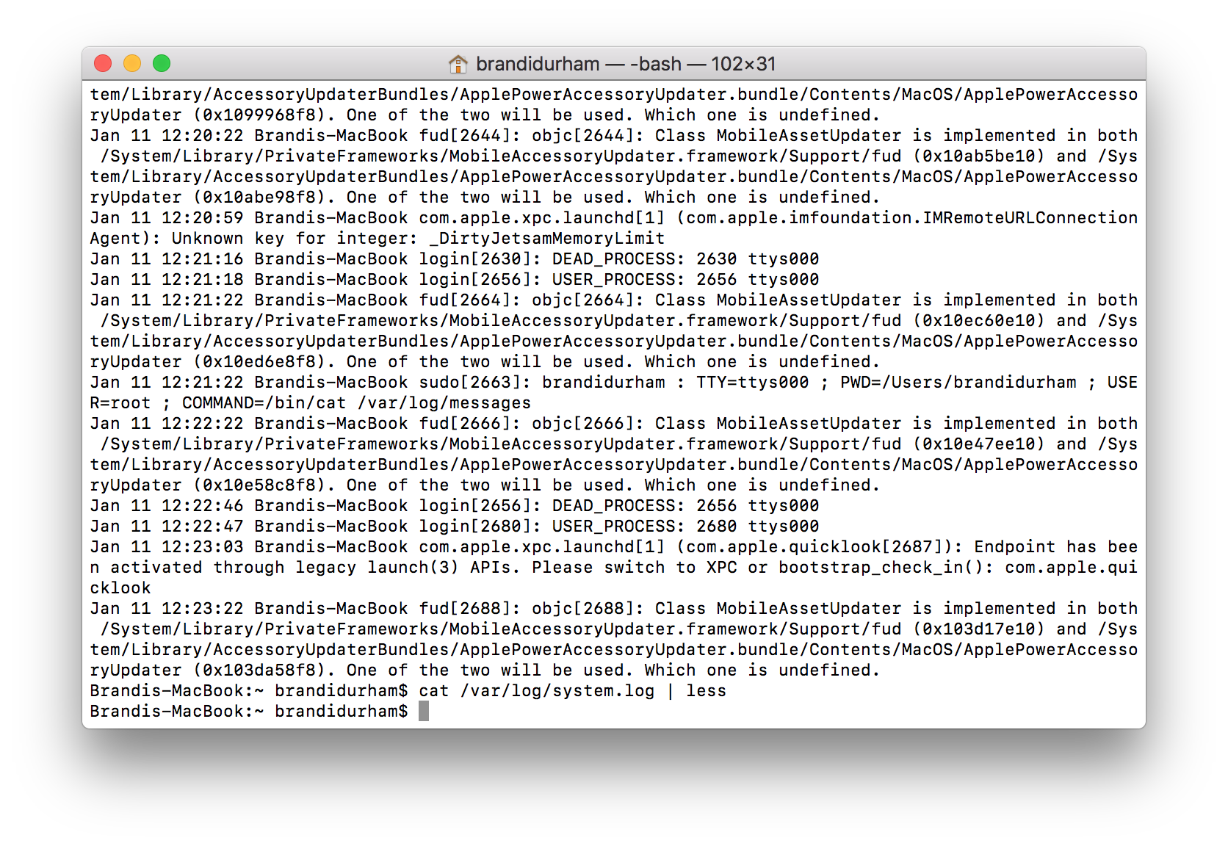

**find . -name "*.txt" | head -n 5**

A.) So it will find files with “.txt” in the filename and output the first 5 results found

**find public_html -name "*.swp" -o -name "*~"**

A.) So this command finds files named “public_html” matching based on the pattern of ending in the “.swp” or “~” filetypes

**find / -mount -mtime 2190 | head -n 5**

A.) This command finds files starting from the root and only traversing the current mounted filesystem it returns the last 5 files modified in the timeframe specified by the -mtime operator.

**Commands used:**

mkdir test

touch compromised.txt

mv compromised.txt test

echo "Writing something random into this txt file">> compromised.txt

chmod 777 ~/Desktop/test/compromised.txt

**What are the differences between ps and top?**

The top command is interactive and lets the user see statistics on the processes running, view processes and see how resources are being used. Top updates periodically and gives you a more real time view. The ps command is not interactive, it displays currently running processes and is meant to be more easily extensible and scriptable.

**Which editor is easier to use, nano or vim? Which one is better?**

Nano is a more simplistic editor, it is easier to use with a less steep learning curve, most of its functionality is presented to the user at the bottom of it’s terminal interface. Vim on the contrary is far more extensible and powerful but presents the user with an interface that relies on memorization rather than understanding. It embodies the unix philosophy of being efficient at its singular task (text manipulation) but our group prefers nano for its ability to quickly modify files. For larger task where more complex textual manipulation is needed we prefer a graphical editor.